Data Science Activity I

- Name: Pradeep Kumar Tiwari
- Semester: 5th
- Roll No: 152337

Single Neural Network :-
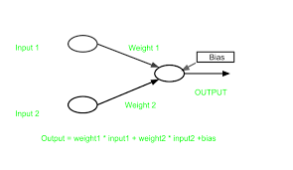
$$Y = f(w_{1}x_{1} + w_{2}x_{2} + b)$$
Data :-
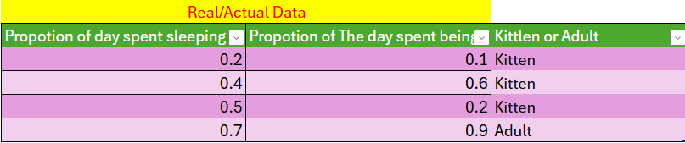

Kitten -> 1
Adult -> 0
For above data set, we take
Activation Funciton :- Step Fucntion
Weight Adaptive law :- wnew= wold + λ * (d - y) * xi ; i = [0,2]

Initial Parameter value
λ = 1
X0 = 1
W0 = w1= w2 = 0

Manually Found Optimal Weights :-

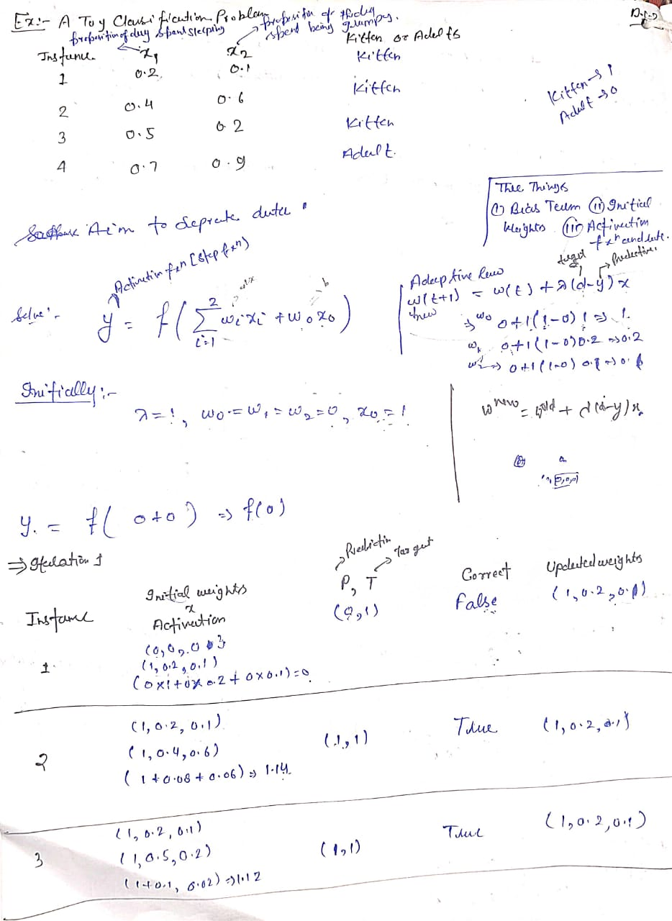

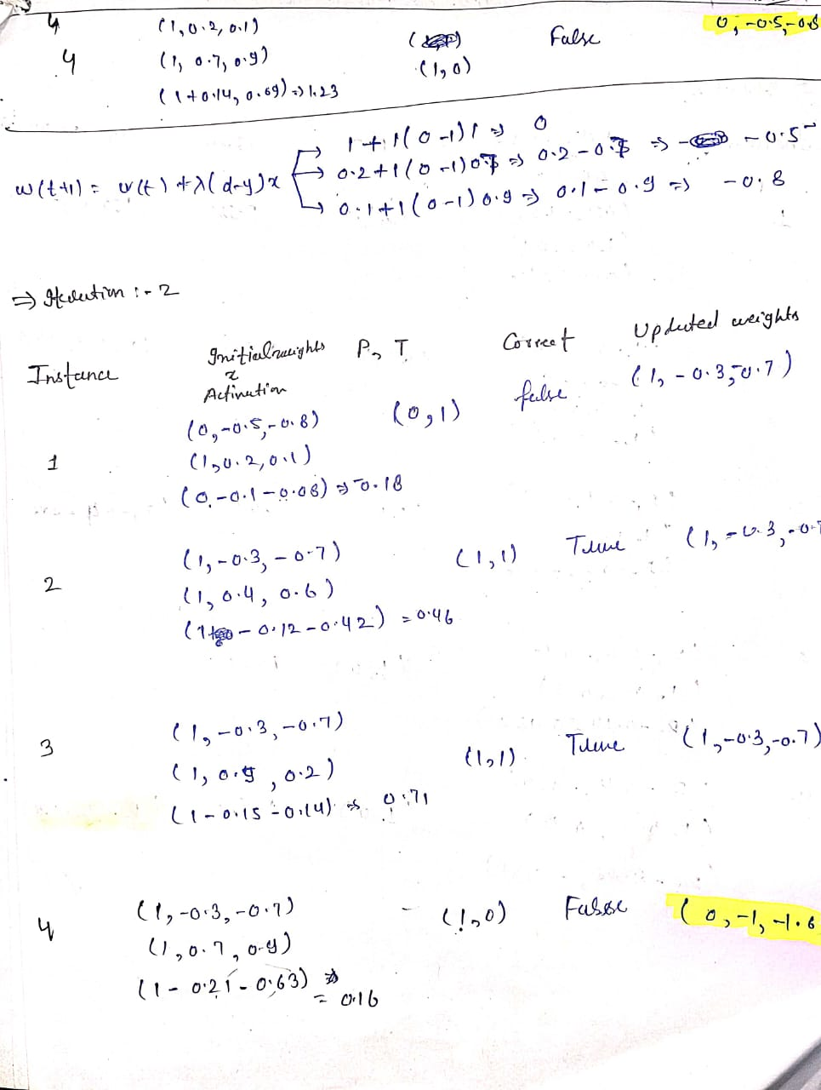
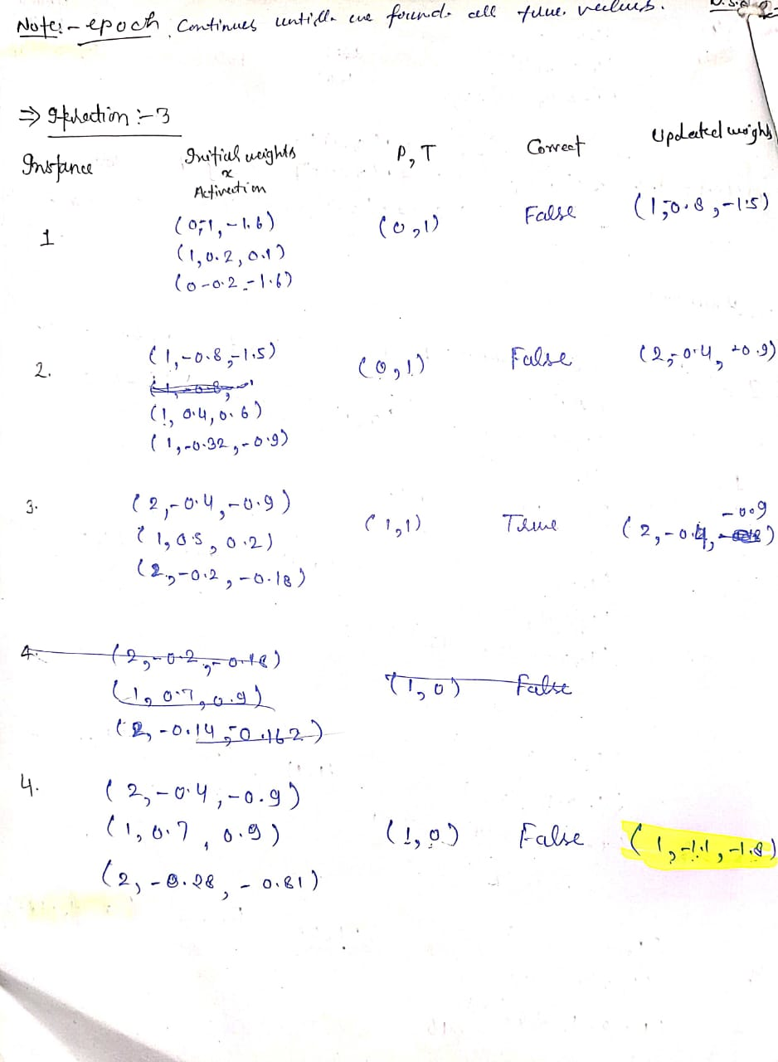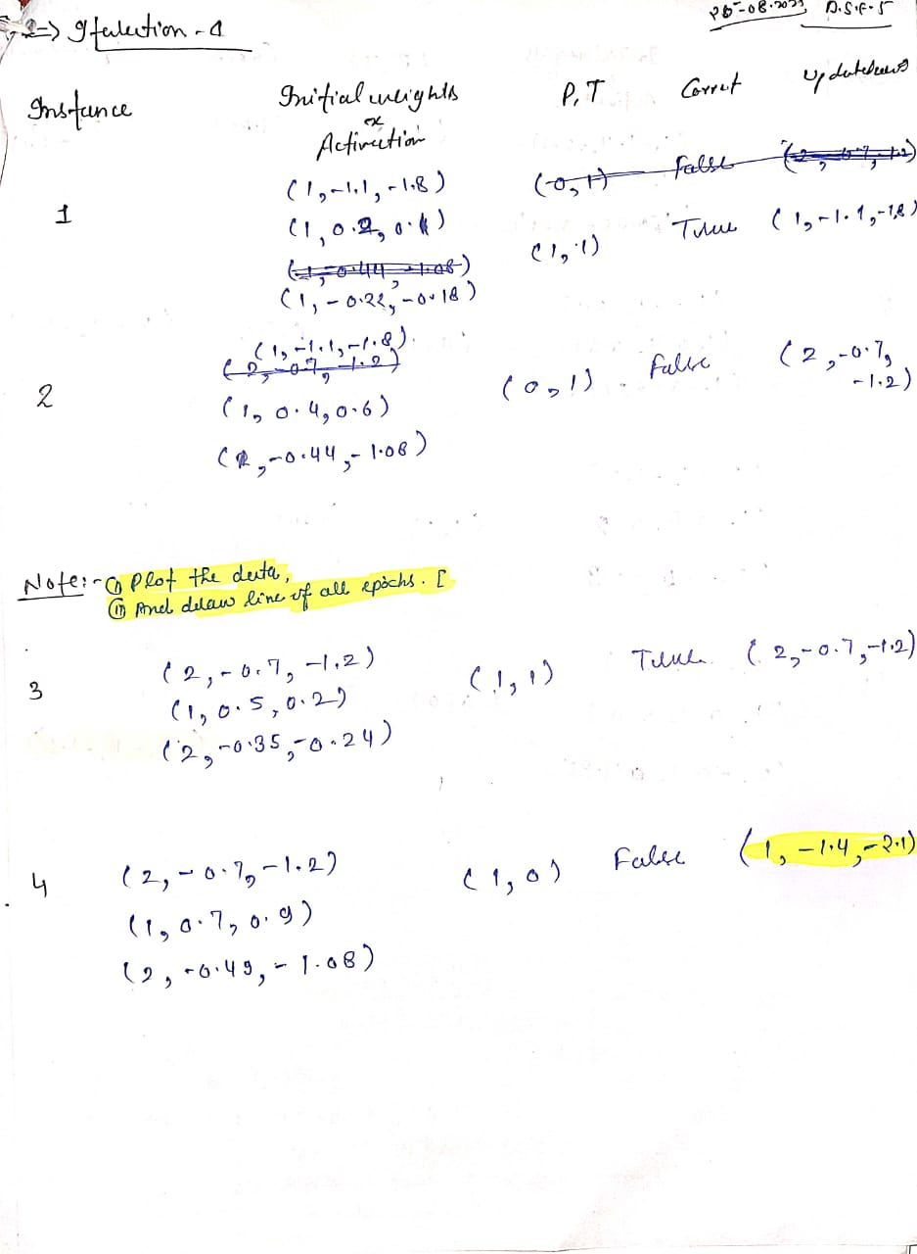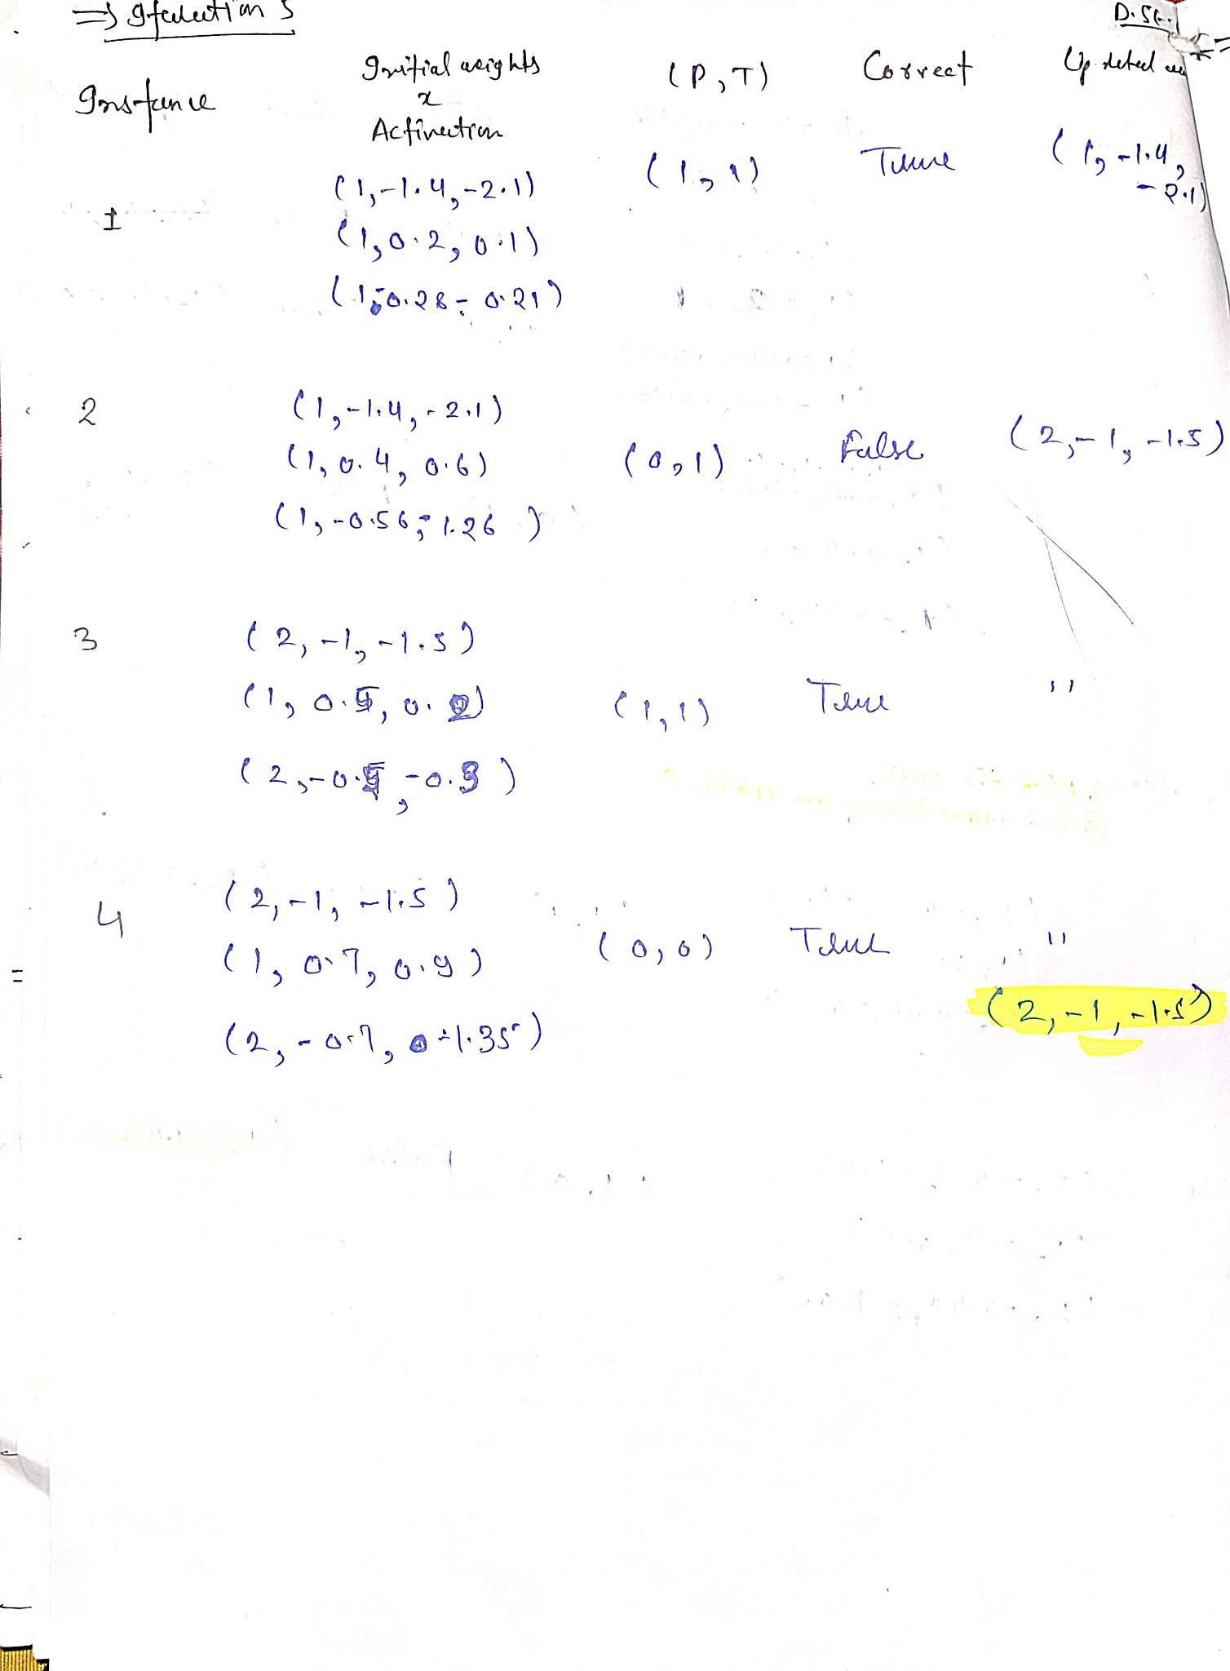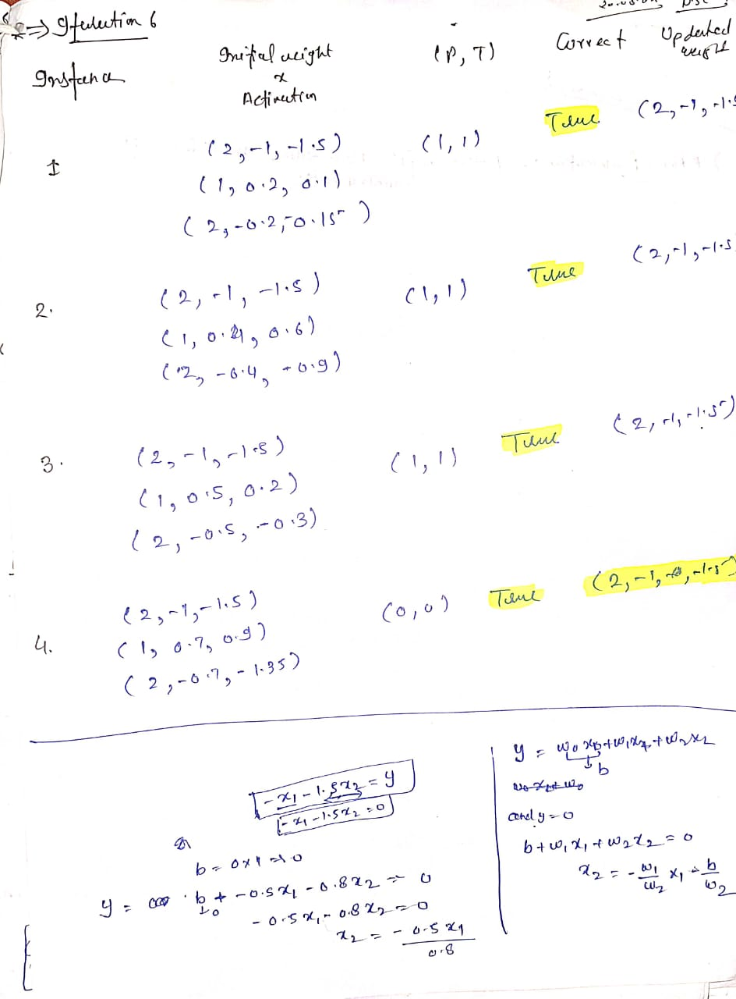

Therefore, in Epoch 5 final weights is found (2,-1,-1.5)

Graph of all 5 epochs :-
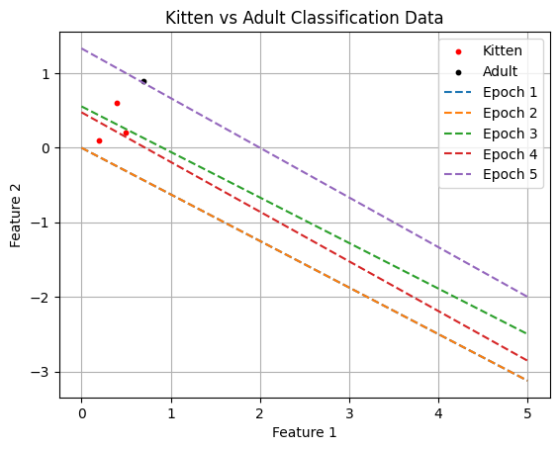

Algorithm for Single neuron(C++) :-

#include<iostream>
#include<vector>
#include<cmath>
using namespace std;
float step_fxn(float);
float sigmoid_fxn(float);
vector<float>single_neuran_step_fxn(float lambda, float w0, float w1, float w2, float x0, vector<vector<float>>& data){
// loop for epochs
int w_not_changed = false;
int count = 1;
while(w_not_changed == false){
w_not_changed = true;
cout << count <<" Epoch :" << endl << endl;
for(int i = 0 ; i < data.size() ; i++){
float b = w0*x0; // bias term
float x1 = data[i][0];
float x2 = data[i][1];
float input = b + w1*x1 + w2*x2;
float y = step_fxn(input); // prediction
// float y = sigmoid_fxn(input);
float d = data[i][2]; // target value
if( y != data[i][2]){
// adaptive law
w0 = w0 + lambda*(d-y)*x0;
w1 = w1 + lambda*(d-y)*x1;
w2 = w2 + lambda*(d-y)*x2;
w_not_changed = false; // check this flag.
}

}
count++;
cout << w0 << "\t" << w1 << "\t" << w2 << endl;
}
cout << "Our Final weights " << endl << endl;
cout << w0 << "\t" << w1 << "\t" << w2 << endl;
cout << "("<< w0 << "," << w1 << "," << w2 << ")" << endl;

return {w0,w1,w2};

}
// first Activation Function
float step_fxn(float input){
if(input > 0.0){
return 1;
}
else{
return 0;
}
}

// Second Activation Function
float sigmoid_fxn(float input){
float threshold = 0.5; // threshold probability
float output = 1 / (1 + exp(-input));
// cout << output << endl;
if(output >= 0.5){ // then o/p is 1
return 1;
}
else { // then o/p is 0
return 0;
}
}
int main(){
vector<vector<float>> data = {
{0.2, 0.1, 1},
{0.4, 0.6, 1},
{0.5, 0.2, 1},
{0.7, 0.9, 0}
};
for(int i = 1 ; i<=4 ; i++){
cout << "x0 = "<< i << endl << endl;
single_neuran_step_fxn(0.25,3,3,3,i,data);
cout << endl << endl << endl << endl;
}
cout << sigmoid_fxn(-0.1) << endl;

}

Observations by changing Four Parameteres :-

1.Weights

2. Activation Function

3. Learning Rate

4. X₀

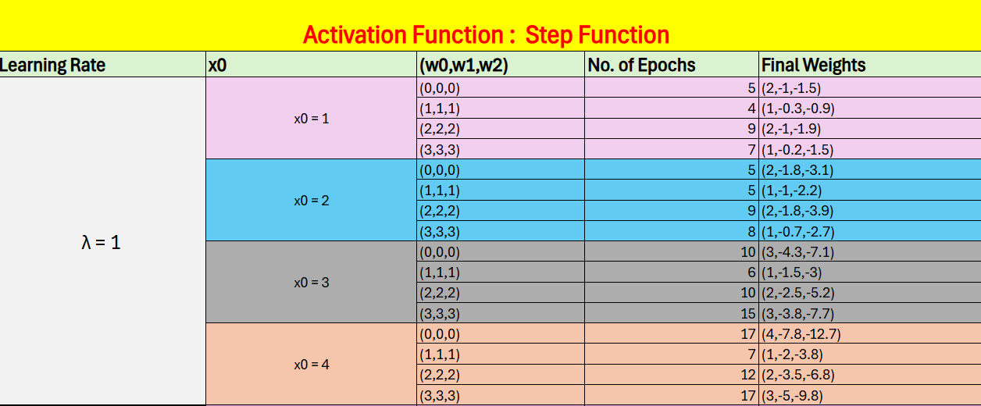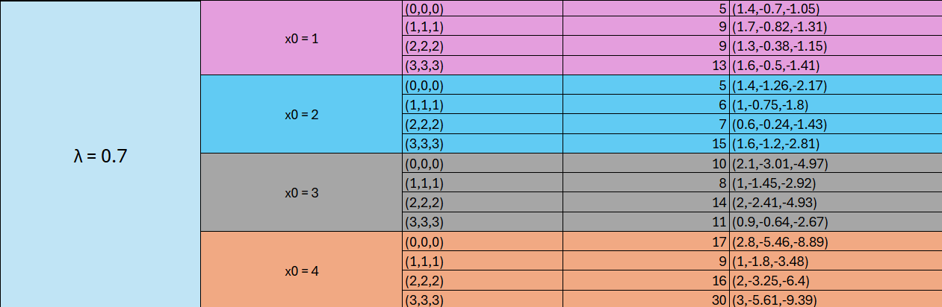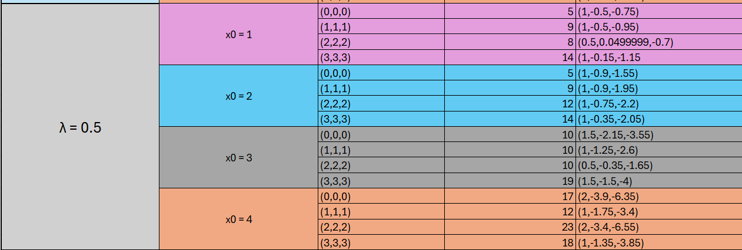
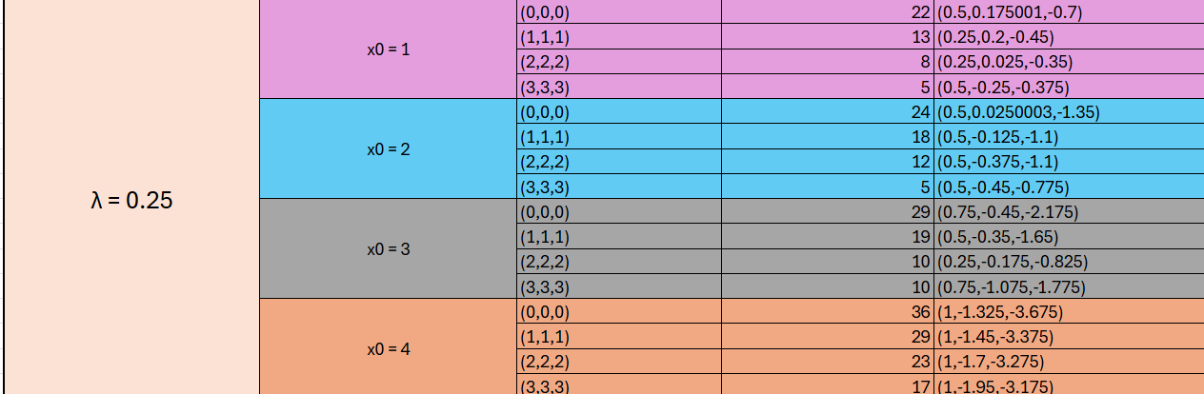

Sigmoid Function :-
